

INFANT & EARLY CHILDHOOD MENTAL HEALTH
Graduate Certificate Program  12 credits
The Infant and Early Childhood Mental Health Certificate at Iowa State University will provide family service, education, and mental health professionals a greater understanding of the factors associated with social and emotional development in young children along with prevention and intervention services that support children and families.
Required Courses
- HDFS 510 Theories of Human Development, 3cr. (fall, on campus/summer, online)
- HDFS 633 Infant Mental Health, 3cr. (spring, even years, online)
Choose 2 of the Following 4 Courses
- HDFS 538 Developmental Disabilities, 3cr. (fall, odd years, online)
- HDFS 567 Family Stress, Abuse and Illness, 3cr. (fall, even years, online)
- HDFS 631, Child Health & Development, 3cr. (fall, even years, online)
- HDFS 632, Behavioral Interventions in Early Childhood, 3cr. (spring, odd years, online)

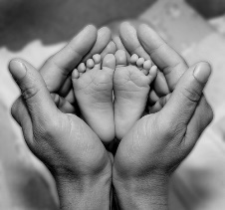

Admission Requirements
- Online Application Fee
- Supplemental Information form-Certificate Program
- Official Transcripts
- Undergrad or grad GPA 3.0
ROLLING ADMISSION

FOR MORE INFORMATION
https://hdfs.hs.iastate.edu/graduate-students/graduate-programs/graduate-certificates/

QUESTIONS? CONTACT
HDFS Graduate Program
515-294-6318
hdfs-grad-adm@iastate.edu

